RELATIONship, Sex & Health Education (RSHE) policy
huddersfield grammar SCHOOL

RELATIONSHIPS, SEX AND HEALTH EDUCATION (RSHE) Policy

Contents

1. Legal framework and linked policies 2
2. Policy context and rationale 3
3. Principles and aims of effective RSHE 4
4. Definitions 5
5. Delivery of RSHE 5
6. Equality, diversity and inclusion 7
7. Curriculum and monitoring 7
8. Responding to pupils’ questions 8
9. RSHE and safeguarding 9
10. Involving parents and carers 9
11. Policy review 10

Legal framework and linked policies
This policy has due regard to legislation and statutory guidance, including, but not limited to the following:

➢ Education Act 1996
➢ Education Act 2002
➢ Children and Social Work Act 2017
➢ DfE (2025) ‘Keeping children safe in education’ (KCSIE)
➢ DfE (2020) ‘Relationships and sex education (RSHE) and health education’
➢ DfE (2025) Relationships Education, Relationships and Sex Education and Health Education (for introduction September 2026)

This policy will be followed in conjunction with the following school policies and procedures:
➢ Safeguarding Policy
➢ Careers Education, Information, Advice and Guidance Policy
➢ Spiritual, Moral, Social, and Cultural (SMSC) policy
➢ Equal opportunities Policy
➢ Online safety policy

Policy context and rationale
This relationships, sex and health education policy covers Huddersfield Grammar School’s approach to teaching relationships, sex and health education (RSHE). RSHE is an integral part of our PSHE curriculum at Huddersfield Grammar School and covers all statutory requirements as per the DFE guidance for relationships and sex education and health education.

Parents/carers, staff and pupils have been consulted during the development and review of this policy.

Children and young people are growing up in an increasingly complex world, navigating both online and offline environments that present significant opportunities alongside definite risks. In line with statutory RSHE and Health Education (2025), Keeping Children Safe in Education and the provisions of the Equality Act (2010) , our curriculum plays a central role in safeguarding by equipping pupils with the knowledge, skills and understanding to recognise risk, stay safe and make informed decisions about their wellbeing, relationships and health.

At our school, RSHE is not taught in isolation but is embedded within a whole-school safeguarding approach. RSHE provides accurate, age-appropriate knowledge alongside the development of personal and social perspectives. It supports pupils to understand boundaries, consent, healthy relationships, online safety and emotional wellbeing, enabling them to manage their lives safely and positively both now and in the future whilst developing the confidence to seek help when needed.

RSHE provision at Huddersfield Grammar School strengthens safeguarding, promotes wellbeing, and supports all our pupils to achieve positive, lifelong outcomes and to contribute meaningfully to society.

Principles and aims of effective RSHE
RSHE provision at Huddersfield Grammar School

- Is an identifiable part of our school curriculum, which planned and integrated across all Key Stages and classes.
- Is taught by staff who have received RSHE training and overseen by Mrs Linda Rhodes (Preparatory) and Mr Liam Fitzpatrick (Senior)
- Works in partnership with parents and carers, informing them about what their children will be learning and how they can contribute at home.
- Delivers lessons where pupils feel safe and participation is encouraged through a variety of teaching approaches with opportunities to develop critical thinking and relationship skills.
- Is based on reliable sources of information, including about the law and legal rights, and distinguishes between fact and opinion.
- Promotes safe, equal, caring and enjoyable relationships and discusses real-life issues appropriate to the age and stage of pupils, including friendships, families, consent, relationship abuse, sexual exploitation and safe relationships online.
- Gives a positive view of human sexuality with honest and medically accurate information so that pupils can learn about their bodies and sexual and reproductive health in ways that are appropriate to their age and stage.
- Gives pupils opportunities to reflect on their values and influences (such as from peers, media, faith and culture) that may shape their attitudes to relationships and sex and nurture respect for different views.
- Includes signposting to sources of help and advice and reliable information online.
- Embeds diversity through an inclusive whole school approach ensuring that all protected characteristics, including LGBTQ+ identities, are represented positively and routinely and all identities are respected all forms of discrimination are challenged.
- Meets the needs of all pupils with their diverse experiences including those with special educational needs and disabilities (SEND).
- Seeks pupils’ views about RSHE so that teaching can be made relevant to their real lives and assessed and adapted as their needs change.
- Ensures setting staff have periodical RSHE training in relation to emerging issues and contextually relevant themes.
- Equips pupils to recognise, critically evaluate and respond to misinformation, disinformation, and conspiracy theories, particularly those encountered online. This includes teaching pupils how to assess the reliability of sources, understand the potential harms of false narratives, and develop digital literacy and critical thinking skills in line with the latest Keeping Children Safe in Education guidance.

Definitions
- RSE involves a combination of sharing information and exploring issues and values.
- RSE is not about the promotion of sexual activity.
- Relationships education focuses on building pupils’ understanding of healthy, respectful relationships of all kinds, including friendships. It includes topics which keep young people safe such as consent, boundaries, communication, and respect for others.
- Health education covers the physical and mental health and wellbeing of pupils. It includes learning about mental health, emotional wellbeing, healthy lifestyles, diet, exercise, substance misuse, and personal safety.
- At Huddersfield Grammar School we define sex education as the teaching of intimate and sexual relationships. Sex education is integrated into relationships education. It includes sex for pleasure, learning about intimate acts and the details of sexually transmitted infections (STIs). Content is delivered in an age-appropriate, factual and non-judgemental way.
- Any content that supports safeguarding—such as consent, sexual health, and understanding contraception for health purposes—is part of our commitment to keeping pupils safe.

Delivery of RSHE

RSHE is delivered by form tutors as part of the PSHE curriculum, timetabled as a planned 60 minute sessions each week. On occasion external visitors, experts and agencies may be invited to contribute to the delivery of RSHE to enhance delivery of these subjects, bringing in specialist knowledge and different ways of engaging with children and young people. When external visitors are used Huddersfield Grammar School will adhere to the principles set out in the DFE statutory guidance 2025. We will only work with external speakers/providers where we have full confidence in their approach, intended outcomes and have viewed all resources to be used.
RSHE is taught through a range of teaching methodologies, such as storytelling, role-play, discussions, individual private reflection, quizzes and fact finding, value spectrums, debating, independent research and artistic presentations. This wide range of teaching strategies promotes engagement by all pupils, irrespective of preferred learning styles.

Roles and responsibilities

The governing board
will approve the RSHE policy and hold the Head to account for its implementation.

The Headteacher is responsible for ensuring that RSHE is taught consistently across the School, and for managing requests to withdraw students from sex education.

The PSHE lead has responsibility for:
- Ensuring that RSHE is delivered in line with statutory guidance and reflects the school’s policy.
- Overseeing all required content is coherently planned and consistently taught across year groups.
- Develops wider staff by identifying training needs, providing appropriate resources, and ensuring teachers have the subject knowledge and confidence to deliver sensitive content safely and effectively.
- Working in partnership with safeguarding leads to ensure the curriculum is responsive to contextual safeguarding issues and the needs of specific pupils or groups.

Staff are responsible for:
- Delivering RSE in a sensitive way
- Modelling positive attitudes to RSE
- Monitoring progress and understanding
- Responding to the needs of individual students

Staff do not have the right to opt out of teaching RSE. Staff who have concerns about teaching RSE are encouraged to discuss this with the Headteacher

Equality, diversity and inclusion
RSHE is delivered to all pupils as part of a broad, balanced and inclusive curriculum, ensuring that every young person can access learning that is appropriate to their age, stage and individual needs. Teaching approaches are adapted to support different abilities, strengths and learning styles, enabling all pupils to participate, develop confidence and make progress.

We are committed to modelling, promoting, and teaching the values of inclusion and empowerment for all. This includes, but is not limited to, upholding the Protected Characteristics as defined by the Equality Act 2010. We promote the needs and interests of all pupils, irrespective of gender, culture, ability or aptitude by creating an inclusive, safe learning environment.

Our approach to tailoring RSHE is underpinned by our commitment to trauma-informed and neurodiversity-affirming practice. Through a relational and responsive approach, we seek to understand and meet underlying needs, creating a safe environment where pupils feel supported and able to engage in learning in a manner which is accessible to them.

Through RSHE, all pupils are given opportunities to explore, question and develop their understanding in a way that respects their background, identity and personal circumstances, preparing them for life in a diverse and inclusive society.

Curriculum and monitoring
RSHE will be taught through a ‘spiral curriculum’. This approach means that pupils will gain knowledge, develop values and acquire skills gradually by re-visiting core themes to build on prior learning. RSHE will support the school’s commitment to safeguard pupils through an age-appropriate curriculum that prepares them to live safely in the modern world.

The statutory components of RSE and health education are taught as part of the PSHE curriculum at Huddersfield Grammar School. The curriculum is structured in accordance with the PSHE Association SEND framework, providing a coherent and progressive framework that supports accessibility, inclusivity and the effective development of pupils’ knowledge, skills and understanding.

Content is delivered using a range of high-quality, evidence-informed resources drawn from reputable and recognised organisations, including edit as appropriate PSHE Association, Cre8tive Resources and the NSPCC. All materials are carefully selected, quality assured and adapted where necessary, to ensure they are appropriate to the age, stage and individual needs of pupils.

Pupils’ learning will be assessed regularly to ensure that that teaching strategies and resources remain relevant and effective, and pupils are making sufficient progress, building on prior knowledge and skills. Assessment activities may include informal quizzes, confidence checkers and confidence scales, responses to scenarios, observations and self-assessment tasks to confirm pupils’ understanding of the topics and address gaps.

Pupils’ knowledge and understanding is assessed through a combination of informal and formal methods that support each pupil’s individual level of engagement and understanding such as 1:1 discussions, role play, responses to stimuli. Where appropriate, formative assessment methods such as written materials and quizzes will be used to monitor progress.

The quality of RSHE teaching and learning will be monitored through RSHE learning walks, team teaching, and informal drop-ins conducted by members of the senior leadership team (SLT) and the PSHE leader. The observations and findings of which will be used to identify and inform future staff training needs.

Consultation with parents and gathering of pupil voice will be conducted on a regular basis to support ongoing evolution of the curriculum to ensure it remains responsive to emerging needs and reflective of pupil’s experiences and contextual needs.

For more information about our RSE curriculum, see Appendices 1 and 2.

Responding to pupils’ questions
RSHE lessons may raise sensitive or controversial issues and some of these may reflect their age or stage, personal or family beliefs, faith or cultural perspectives. We believe that children are best educated and protected from harm when they are provided with a safe and supportive space to discuss issues. In RSHE sessions pupils are encouraged to ask questions openly within the class working agreement or anonymously using a questions box. Teachers will provide answers that are age and stage appropriate, based on pupils’ understanding.

Our whole-school culture recognises the importance of RSHE and our commitment to keeping pupils safe. We recognise pupils may ask questions about RSHE topics outside of planned lessons, and these questions may be directed to any member of staff. As part of our commitment to safeguarding, staff will use their best endeavours to respond with patience, empathy and understanding in a manner that is age and stage appropriate. However, if a staff member is unable to answer a question, then questions may be deferred to enable staff to consult colleagues or senior leaders, so an appropriate response is provided. Staff may refuse to answer questions that are inappropriate or personal to themselves, explaining the reason and guiding pupils to reliable sources, including parents or trusted adults.

RSHE and safeguarding
The school’s responsibility to safeguard pupils through a curriculum that prepares them to live safely in the modern world is central to the planning and delivery of RSHE.

Designated Safeguarding Leads (DSLs) work closely with PSHE/RSHE leaders to ensure safeguarding is fully embedded within curriculum content, teaching approaches and resources. This is a two-way process: staff delivering RSHE will share emerging themes, concerns or contextual safeguarding risks identified through classroom discussion, enabling DSLs to respond proactively. In turn, DSLs support staff to plan and deliver content sensitively, particularly where pupils may be vulnerable or where topics may be difficult due to the student’s own prior experiences or trauma.

RSHE is delivered using appropriate distancing techniques, such as scenarios or characters, to ensure pupils can engage safely without pressure to disclose personal information. Staff signpost pupils to appropriate sources of support and work closely with pastoral systems and clinical teams to ensure timely responses to emerging needs. Any disclosures or concerns arising during lessons are treated as safeguarding matters and reported immediately to the DSL, in line with the school’s safeguarding policy.

Involving parents and carers

We believe that RSHE is most effective when it is in collaboration between school and home. We therefore wish to build a positive and supporting relationship with parents/carers of children and young people at Huddersfield Grammar School through mutual understanding, trust and cooperation.

The school will proactively engage parents and make sure they are aware of what is being taught in RSHE and consult with them when developing and reviewing the RSHE Policy, through an annual survey. A representative sample of the resources used is available as an appendix to this policy. Parents are able to view other curriculum materials used to teach RSHE on request. The school will provide support to parents and carers through an annual workshop which provides a valuable opportunity to develop awareness of emerging RSHE topics, review the resources being used and discover ways to build on the learning at home. Our school also operates an open-door policy enabling parents to discuss RSHE at relevant times throughout the school year.

Right to withdraw
There is no right to withdraw from Relationships Education or Health Education. Parents and carers may request that their child is excused from Sex Education, taught outside of the national curriculum for science. If a parent wishes their child to be excused from some or all the non-statutory Sex Education, they should discuss this with Mrs Olivia Wareham, making clear which sessions they do not wish their child to participate in. The Headteacher will outline to parents/carers the benefits of receiving this important education and any detrimental effects that withdrawal might have on the child. This could include any social and emotional effects of being excluded as well as the likelihood of the child hearing their peers’ version of what was discussed in classes rather than what was taught directly. Once a decision has been made, parents/carers must inform the school in writing stating their reasons as to why they would like their child withdrawn. A copy of withdrawal requests will be placed in the pupil’s educational record.

Following the decision, except in exceptional circumstances, Huddersfield Grammar School will respect a parent/carers’ request to have their child withdrawn from non-statutory sex education up to and until three terms before the child turns 16. After that point, if the child wishes to receive sex education, rather than be withdrawn, the school will provide the child with sex education during one of those terms and document this process.

If a pupil is excused from sex education, the school will ensure that the pupil receives appropriate, purposeful education during the period of withdrawal.

Where a question arises that is necessary to safeguard a pupil or to address potentially harmful myths or misinformation around sex education topics, staff will provide an appropriate, factual and sensitive response which will be recorded on school safeguarding systems and follow the schools' safeguarding policy. In such cases answers will be framed to support pupil's safety, wellbeing and
understanding.

Policy review
Consultation with families and pupils will be conducted on a regular basis to support with reviewing the curriculum to ensure it remains responsive to emerging needs and the policy updated accordingly.

This policy will be annually or sooner if the RSHE curriculum is amended, for example in response to emerging themes, changing pupil needs or introduction of new legislation and guidance.

This RSHE policy is currently aligned with the Department for Education Relationships Education, Relationships and Sex Education and Health Education Statutory Guidance (2025).

- Appendix one
- Curriculum coverage PSHE, RSE and health education
Preparatory use the Jigsaw Scheme of Work from Early Years to Year 6.
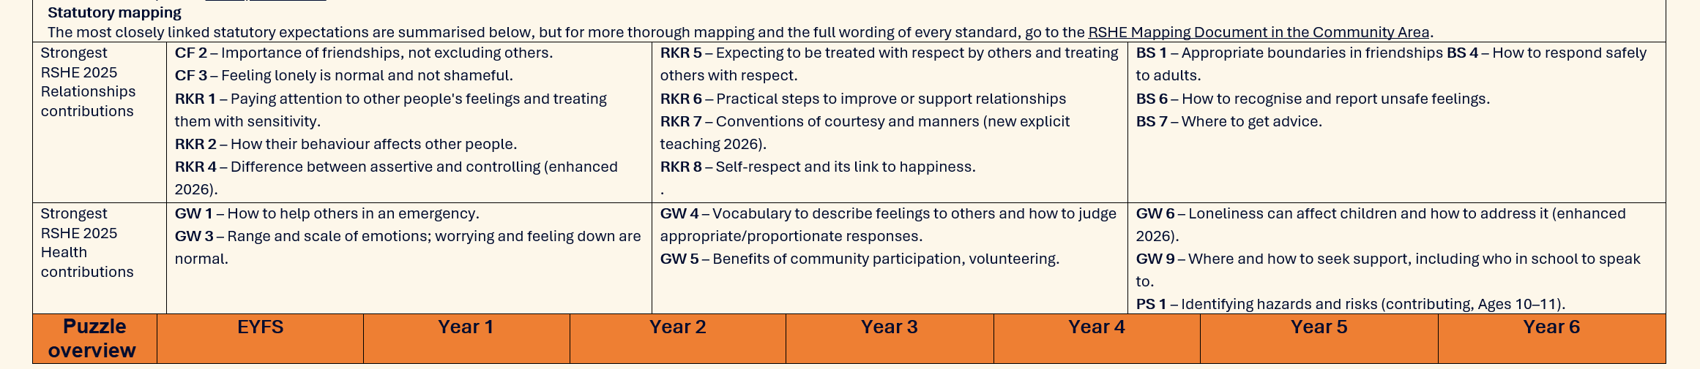
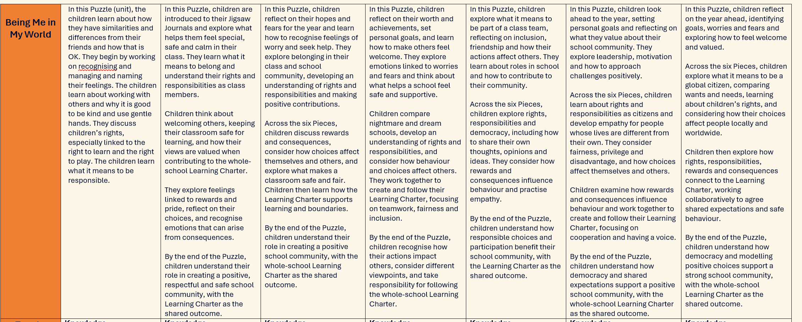

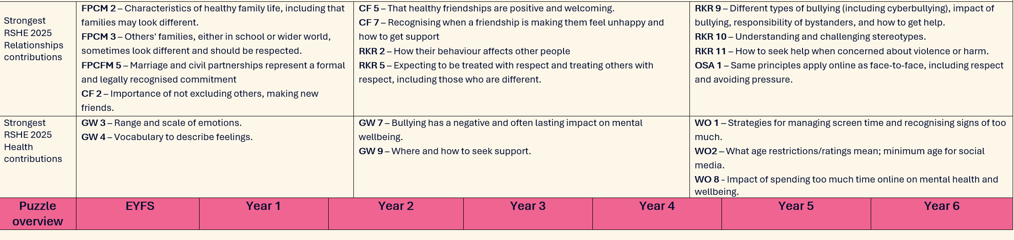
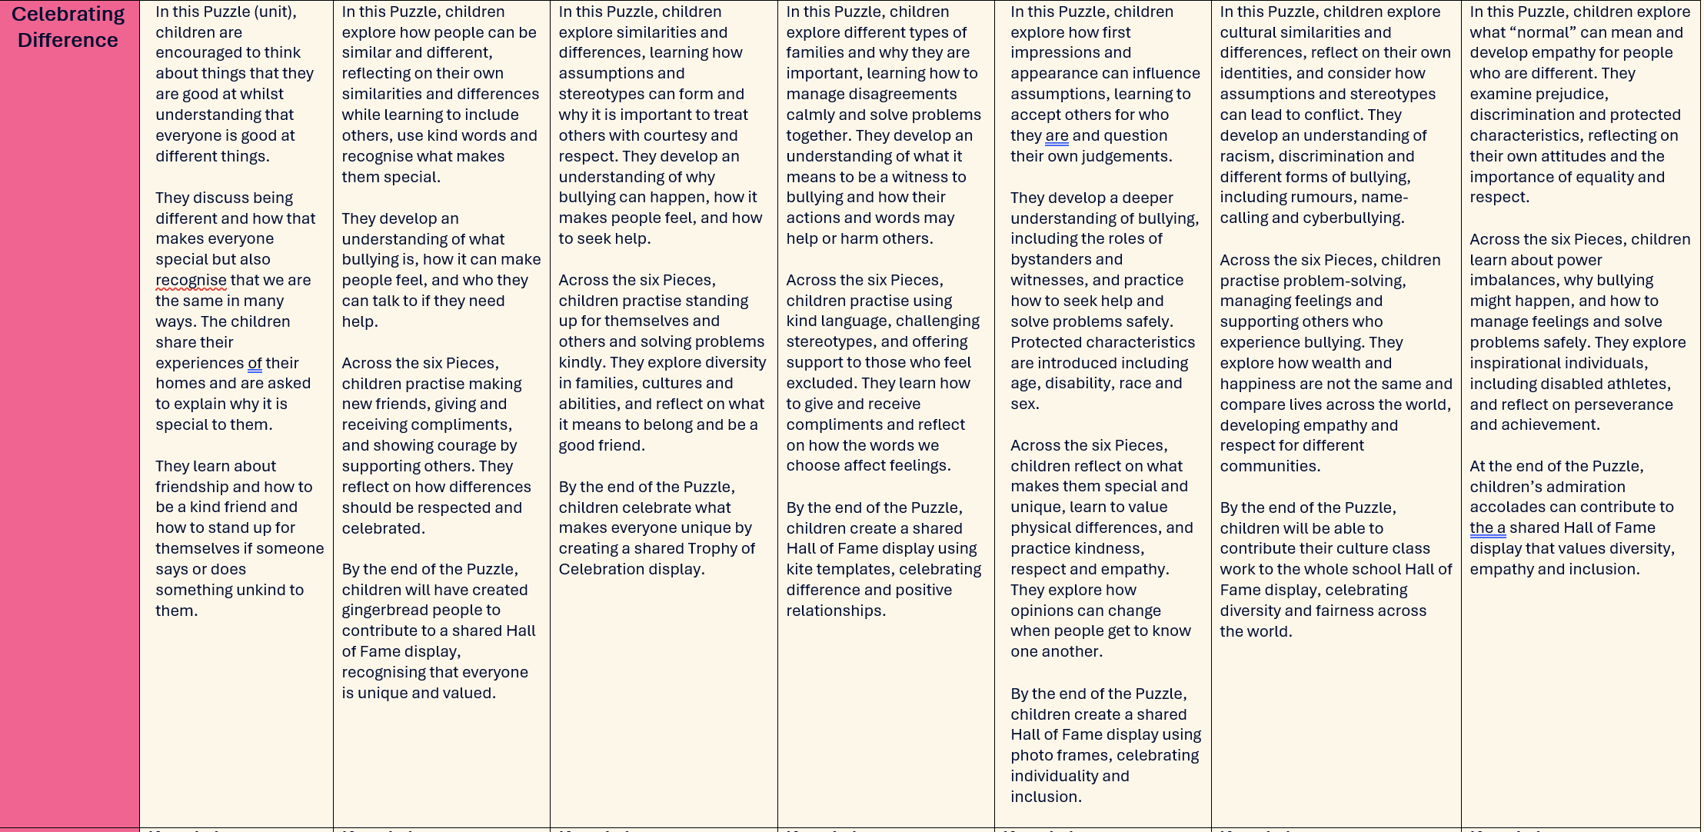

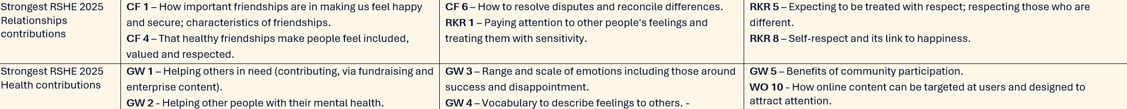
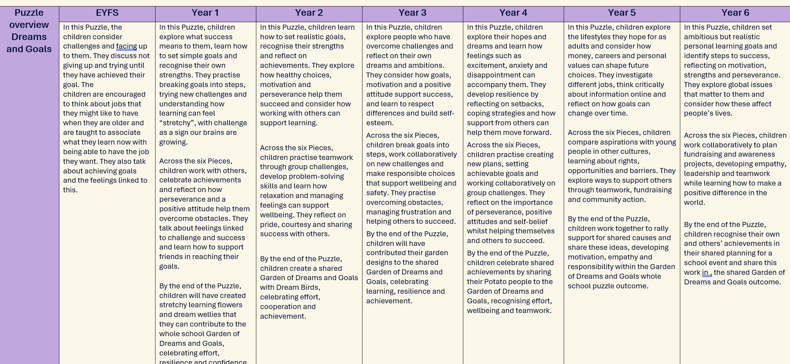

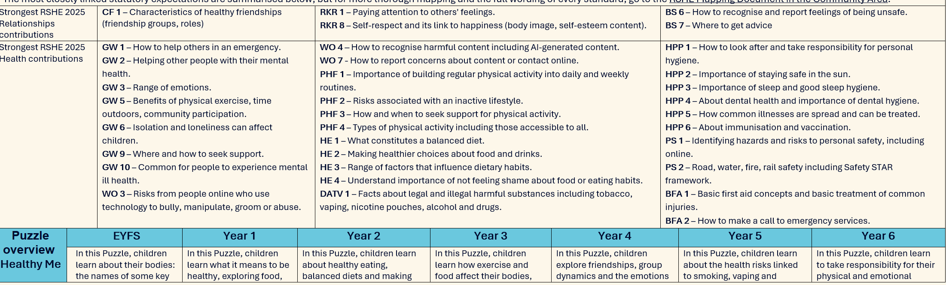
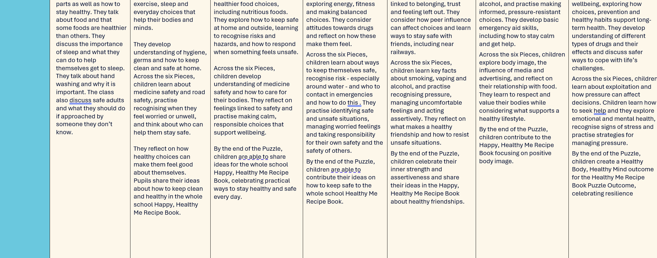

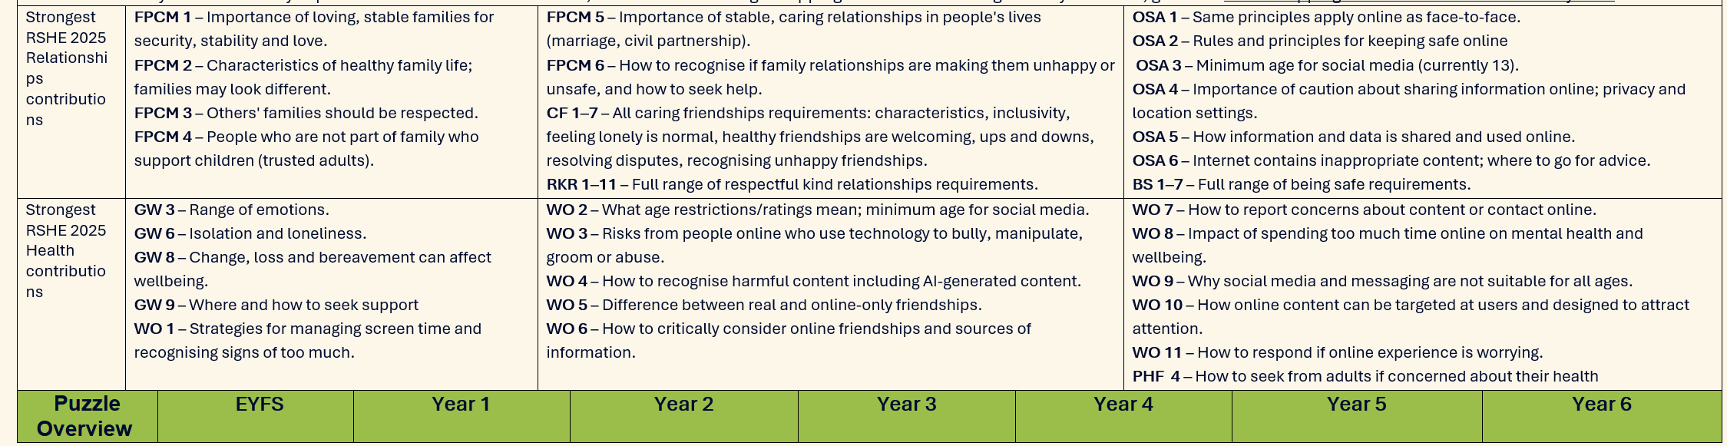
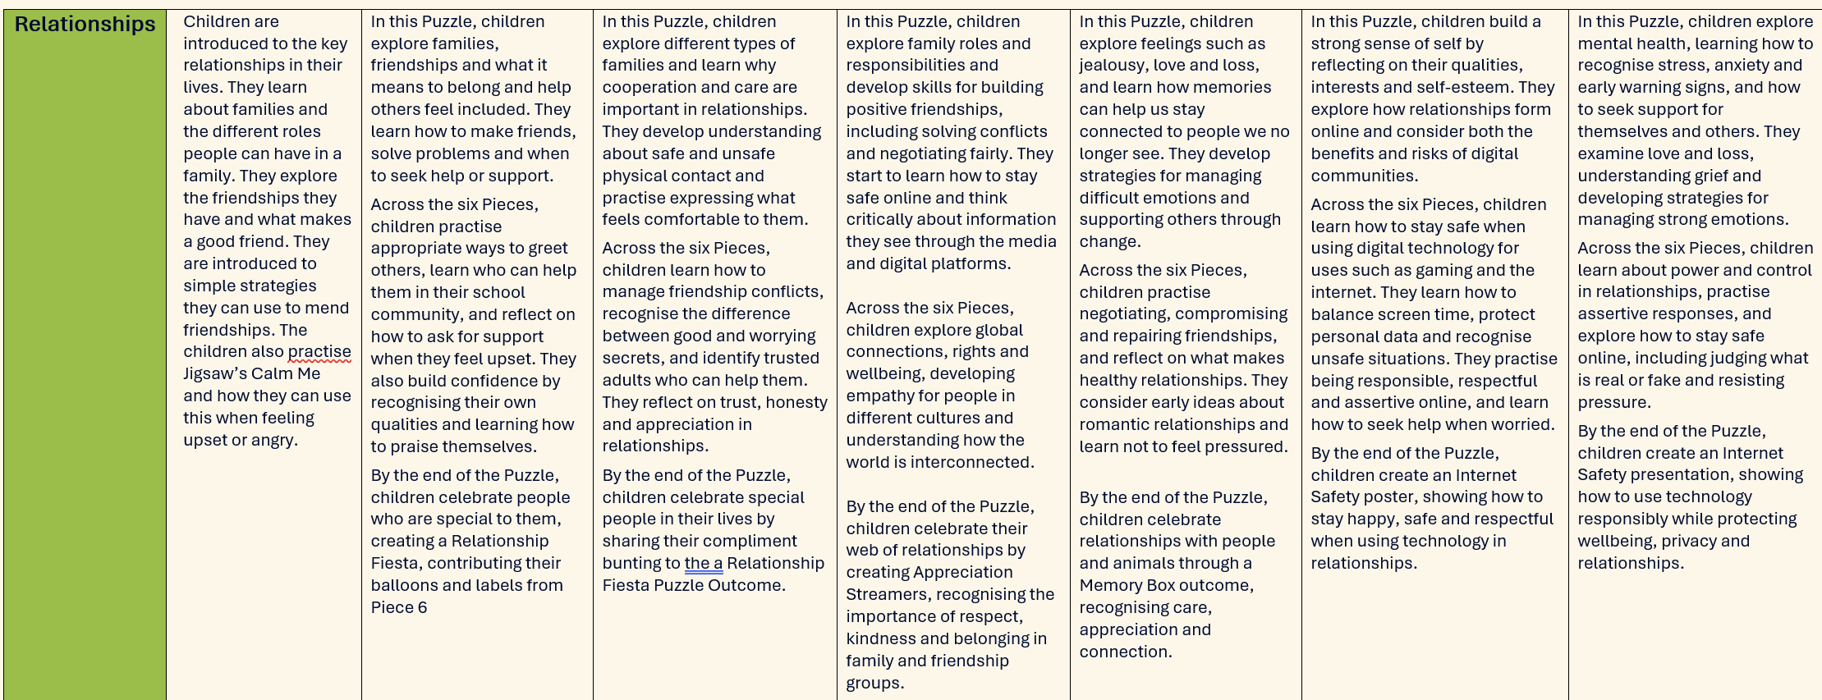

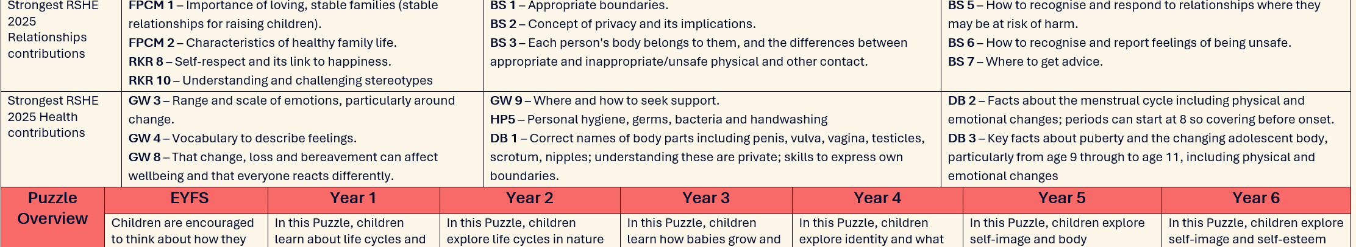
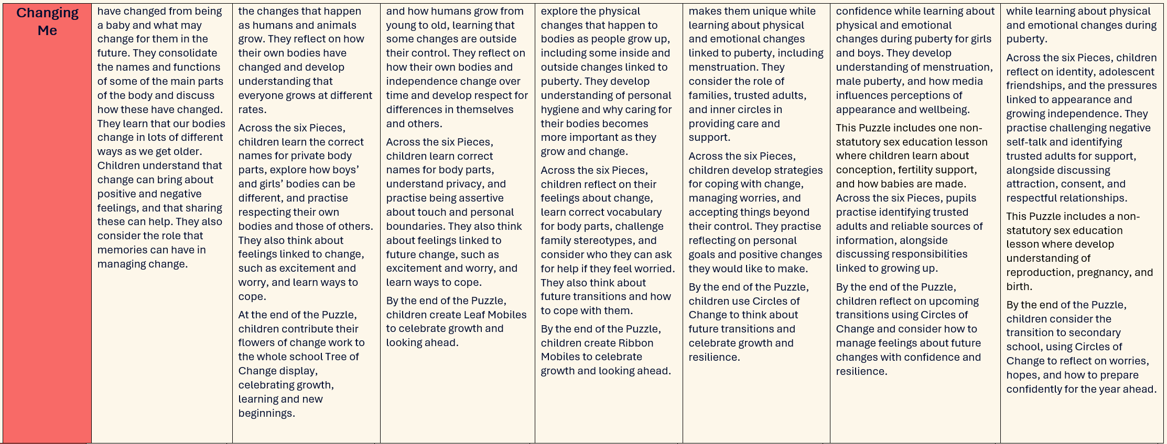

KS3
Year 7 | Autumn 1 | Autumn 2 | Spring 1 | Spring 2 | Summer 1 | Summer 2
PSHE assoc. programme of study links | H30, H32, R17, H2, H6, H11, H12, R1  L1, L2, L3, L4, L5, L6 | R1, R2, R13, R14, R24, R25, R26, R27, R36, R41, R42, R43 | R3, R40, R41, L10 | H19, H20, H34, H15 | H6, H8, H24, H25, H26, H27, H28 | L7, L8, L9, L12, L15, L16, L17
Content | Theme – Self-esteem  What is PSHE? Ground rules. Getting to know others in my class, build relationships and think about own needs and worries. Learning about self-esteem and what it means. Having a positive relationship with myself. Recognising what loneliness is and how to manage. Linking this to time online (especially to combat loneliness) and awareness of how online behaviours can present risks. | Theme – Respect  Learning about what constitutes consent and why consent should always be respected, including personal space and boundaries. Considering what makes a respectful relationship and why this is important – including online relationships and what we share online. Recognising peer influence in relation to risk taking online and offline. Learn ways to be assertive and advocate for oneself. Revisit relationships with family in context of respectful relationships | Theme - Diversity  Learning about identity and reflecting on own identity and the various components that contribute to our identity. Accepting difference and being proud of our identity.  Content around neurodiversity – link to cohort being taught.  Stereotypes and what they mean. British values around equity, equality and both the local community and country. Respect differences and being tolerant of others’ beliefs.  Touch on misogyny if appropriate for class. | Theme – Puberty  Exploring puberty and what it means for different genders building on prior learning from primary phase. Consider brain development and changes over time as well as implications for physical and emotional health. Looking at hygiene and general care of our bodies including teeth.  Looking at the balance of time online and offline, linking to physical and mental health and how online content can impact wellbeing. | Theme – Alcohol, tobacco, vaping  Understanding the risks associated with drugs, including vaping. Physical and psychological risks associated with excessive alcohol consumption. The effect of alcohol on wider society.  Understanding why some people may want to smoke, vape etc  Understanding that all people feel a range of emotions, but do not always respond in the same way to similar situations. | Theme – Independence  Understanding the meaning of the word career. Awareness of what considerations are involved in making realistic choices about the future and safe choices as one becomes more independent.  Could look here at relationships in the home and who we trust to help us – revisiting content from KS1/KS2  Looking at money and basic skills around managing it.
Statutory links | Respectful relationships 3  Mental wellbeing 3  Wellbeing online 1, 2 | Respectful Relationships 1, 5, 8  Personal Safety 2, 3  Being safe 1,2, 3  Families 8 | Respectful Relationships 4, 5, 6, 9, | Wellbeing online 1, 2, 7  Physical heath and fitness 1  Health protection and prevention 2, 6  Developing bodies 1, 2 | Drugs, alcohol, tobacco and vaping 1, 3, 4, 6, 7  Mental wellbeing 1, 2, 4, 9 | Personal Safety 1  Families 8

Year 8 | Autumn 1 | Autumn 2 | Spring 1 | Spring 2 | Summer 1 | Summer 2
PSHE assoc. programme of study links | R1, H6, H7, H9, H1, H11, H12, L2 | H3, H4, H5 H6,H10, H11, H12, H13, H14, H16, H17, H18, H34 | R14, R23, R37, R38, R40, R44, R45, R46, R47  L20, L21, L24, L27 | R4, R5, R7, R8, R9, R38, R39, R40 | R1, R3, R4,R5  H35, H36  May contain defined Sex Education elements | H26, H27, H28, H29
Content | Theme – Healthy minds  Build on learning about identity and self-esteem. Know that feeling down when things don’t go to plan is normal and a range of feelings is part of life.  Recognise strategies for aiding wellbeing.  Defining the term mental health and knowing when to seek help.  Exploring what happiness might mean to different people.  Exploring how our feelings can impact what we do and say Managing anger and stress. Revisit the importance of screen free time.  Light touch on how the media and social media can impact how we feel about ourselves and how content /adverts are targeted which may reinforce this. | Theme – Healthy Bodies  Understand what body image is and how it links to our feelings and our identity. The impact of comparing ourselves to images we see in the media or online. Revisiting body terminology and anatomical names.  Explore components of a healthy diet. Look at risks of obesity and links between poor diet and poor health. Thinking about how to replace unhealthy snacks and foods with healthier alternatives  Self-care for minor ailments and the role of GPs and doctors and taking responsibility for our own health.  How germs are spread and treatments – link to  antibiotics and what they are for (link to science if possible)  Understanding what happens during the menstrual cycle and common gynaecological issues. | Theme – Risky behaviours  Exploring the different forms of bullying. The impact they can have and where to seek support or advice.  Managing oneself appropriately online, seeking support for harmful behaviours or by content seen or shared.  Learn about exploitation and from stories of those affected. Explore risks online including grooming.  Link to offline risks and the reasons why young people might want to join a gang. Understand that there are risks and consequences to illegal behaviour on and offline such as knife possession or supply or the purchase or supply of drugs. Know what the laws are.  County lines if contextually appropriate. | Theme - Equality  What equality means, Equality Act and why it is important.  Exploring and celebrating a variety of LGBT+ Role Models in British society and recognise there are different types of committed relationships.  Looking at equality in other forms including gender and disability. Hearing the stories and perspectives of others with lived experiences.  Know what misogyny, racism and discrimination mean and have open discussions about language and what is and is not appropriate.  Recognise that stereotypes can cause damage – students should recognise prejudice in different forms. | Theme- Intimacy  Understanding how physical touch may be different in a sexual relationship. What rights in relationships look like.  Compare and contrast the characteristics of healthy and unhealthy relationships. Look at respect in a healthy relationship looks like. Look at a range of contraceptive methods* (more detail in yr 9). Look at age of consent and the law. Note that sex when over the age of consent and a person is ready should be positive and enjoyable.  Explore sexual orientation through lived experience scenarios, associated language and discuss prejudice and attitudes. | Theme -Safer decisions and seeking help  Look at how to develop key social and emotional skills to increase safety from violence or harm - this should include the opportunity to make decisions using scenarios that involve substance abuse, knife crime and conflict.  Look at stories and narratives around why young people may take risks.  Explore warning signs that someone might need help. Know who to talk to and where to access support and help for any form of abuse (child, domestic, substance etc)  Look at the impact of alcohol on health linking to diet and unhealthy weight gain.
Statutory links | Mental wellbeing 1, 3, 4, 5, 6  Physical health and fitness 3  Online safety and awareness 8, 13 | Healthy eating 1, 2  Health protection and prevention 1, 3, 5, 8,  Developing bodies 3, 4  Basic First Aid 1 | Wellbeing online 3, 6  Personal safety 3, 4, 5, 6  Online safety and awareness 1, 9, 10 | Families 1, 2  Respectful relationships 1, 2, 4, 5, 9 | Intimate and sexual relationships 1, 2, 3, 4, 5, 6*, 11  Respectful relationships 1, 8, 10  Being safe 1, 2 | Drugs, alcohol, tobacco and vaping 1, 3, 5  Personal safety 2, 3, 4  Being safe 3, 4, 5  Intimate and sexual relationships 10  Healthy Eating 3

Year 9 | Autumn 1 | Autumn 2 | Spring 1 | Spring 2 | Summer 1 | Summer 2
PSHE assoc. prog of study links | R20, H24, H25, H26, H27, H28 | H22, L23, L24, L25, L26, L27 | R10, R24, R25, R26, R27 | R22, H19, H21, H31, H33 | R11, R12, R28, R31, R32, R33, R34  May contain defined Sex Education elements
Content | Theme - Drugs  Build on previous content looking at different types of drugs. Explore the link between gangs, users and illegal drugs.  Look more widely at drug trade and link to current affairs and policies.  Medical drug misuse.  Revisit self-esteem, mental health and the impact of media including social media content on self-image, body image and identity.  Explore why people do not necessarily respond in the same way to similar situations and that different people may express their feelings in many ways.  If appropriate can look at serious risks of viewing material online that promotes self-harm etc to deal with low self-esteem | Theme – Extreme views  Explore why people may choose to commit an act of terrorism and look at forms of extremism.  Revisit tolerance and treating others with kindness and respect, including the way we conduct ourselves online.  Looking at how to determine whether sources of information are trustworthy and to critically evaluate content for bias/opinion.  Online scams and fake websites linked to criminal behaviour.  The physical and emotional damage done by FGM and virginity testing and the laws related to this. | Theme – Consent or control?  Look at how inequalities can affect the balance of power in relationships including sexual relationships. Recognise when a relationship is unsafe.  Laws relating to domestic abuse inc. coercive behaviour and emotional abuse. Assertive vs controlling. Looking at lived experience stories in this context, sexual harms including harassment and inappropriate language. Learn sexual violence is never acceptable and never fault of victim. Revisit & expand on consent in different scenarios. Emphasise consent cannot be assumed and can be withdrawn. Look at the creation of sexual imagery in this context. Teach laws for sexual images, forwarding images of YP under 18 even if image is of oneself. Learn about sextortion. Signpost help services. | Theme – Learning for life  Learning lifesaving skills, including CPR and what defibrillators are for and where they are located (inc. locally)  Learning about difficult subjects -conflict, divorce, managing grief and looking at prevention to support own health.  Introduction to the topic of ending relationships and feelings when a relationship ends, including friendships – looking at conflict and kindness.  Some of these subjects may be triggering for some students. | Theme – Sex and STIs  Exploring sex and that choices made can impact positively and negatively on wellbeing. Learn about the prevalence of STIs and the importance of condom use – male and female (expand on content from year 8). Look at HIV and AIDS. Explore a range of contraception (use tangible resources).  Know where to access free condoms (e.g. C-card) and how to use them. Know where to go to seek advice on both contraception and sexual health.  Revisit consent.  Could look at Gillick competence here in relation to seeking support for contraception etc | Theme - Resilience  Explore strategies to build resilience. Looking at when things go wrong and how to cope and move forward.  Look at lived experience of overcoming barriers in a range of contexts.  Consider barriers in own life and how to overcome these.  Look at key concepts of assertiveness and motivation.  Looking at how social media can give unrealistic expectations of life (link to earlier work on this area regarding body image).  Explore the link between social media and stress/poor mental health.
Statutory links | Drugs, alcohol, tobacco and vaping 1, 2, 3, 6  Mental wellbeing 4,6, 7  Wellbeing online 2, 7 | Online safety and awareness 9, 10, 12, 14  Being safe 13 | Being safe 5, 6, 7, 8, 9, 10, 11, 16  Intimate sexual relationships 3, 5, 11  Online safety and awareness 4, 5, 6, 15 | First Aid 2, 3  Families 6, 8  Health protection 4  Mental wellbeing 3  Respectful relationships 7 | Intimate sexual relationships 2,3,4, 6,8, 9, 12  Health protection and prevention 9 | Mental Wellbeing 1, 6, 7  Wellbeing online 2, 7 (if appropriate or defer to KS4/5)  Online safety and awareness 3, 8

KS4
Year 10 | Autumn 1 | Autumn 2 | Spring 1 | Spring 2 | Summer 1 | Summer 2
PSHE association programme of study links | H3, H6, H7, H8, H9, H12, H17, H18  R35, R36, R37, R38, L24 | R2, R8, R19, R21, R22 (+ KS3 R29, R30) R28, R29, R30, R31, R32  May contain defined Sex Education elements | R33, R34, R40  L27, L28, L29 | L1 L13, L14, L25, L263 | H25, L16, L17, R37, R38, L23, L26, L27, L28, L29
Content | Theme – Mental health and mental illness  Revisit self-esteem and the link between screen time and wellbeing.  Revisit the difference between normal feelings of being down and anxiety and depression as mental illnesses.  Link to bi-directional relationship with alcohol and drugs.  Lessons on self-harm and suicide in conjunction with DSL guidance. | Theme – Sex online and offline  Exploring healthy sexual relationships, building on prior learning of healthy sexual behaviours & consent. Relationship scenarios including range of relationships.  Making decisions related to sex and sexual behaviours. Laws related to sharing online and impact of this.  Learning some sexual behaviours can be harmful & recognising when a relationship is harmful. How to report concerns about abuse or harmful online content and the vocabulary needed to do so. Explore how pornography can influence others and normalise unhealthy/ harmful sexual behaviours. Opportunities to discuss subcultures such as incels and impact of influencers.  Revisit Gillick competence. | Theme – Mutual respect  Exploring the damaging consequences of fake news and understanding why critical thinking is important.  The difference between free speech and hate speech. Defining British values and our sense of identity. Understanding how multiculturalism and diversity play a big part in teaching us respect.  Looking at practices which are not acceptable and are illegal in the UK – marrying under 18 and forced marriage.  Defining the terms honour and dishonour Exploring honour-based violence and the different forms it can take and promoting the equality of women in our society. | Theme – Advertising, algorithms and misinformation  Looking at how advertising and information is targeted to different audiences and demographics and how information is generated, collected and shared online.  The risk of viewing harmful content online and how this can happen by accident – revisiting how to report this. Revisit pornography and content presenting a distorted picture or narrow viewpoint.  Look at rights, responsibilities.  Work on identifying when technology and social media is used for coercive, abusive or illegal behaviours and revisit where to seek support.  Exploring deepfakes and how to identify them as well as the laws, impact and consequences of creating and sharing. | Theme - Influence  Risks relating to online gambling content and the accumulation of debt.  Revisit age-appropriateness of games/sites and why age ratings are needed.  Build on prior learning about social media creating an unrealistic picture and expand into how we can fall into the trap of needed validation online. Look at external pressures in relation to young people online and offline – looking at knives, pressure to join gangs, pressure to modify body or reach unhealthy goals with appearance – to look or act a certain way.  Social media conflicts and signposts for help and advice. | REVISITS as required  Plus enterprise and community projects
Statutory links | Mental wellbeing 2, 3, 4, 9  Wellbeing online 1, 7 | Being safe 5, 6, 7, 8, 14, 15, 16  Online safety 5, 8, 11,  Respectful relationships 8, 11, 12  Intimate and sexual relationships 3, 4, 5  Health protection 9 | Families 5  Being safe 12  Wellbeing online 3, 5  Respectful relationships 2, 4 | Online safety and awareness 2, 6, 7, 10, 11, 12, 13 14,  Wellbeing online 5, 6 | Online safety and awareness 2, 12, 13,  Mental wellbeing 8  Wellbeing online 2, 4, 5

Year 11 | Autumn 1 | Autumn 2 | Spring 1 | Spring 2
PSHE association programme of study links | H2,H3, L22, L24, L25 | R1, R3, R4, R9, R10, R14, R23, R24, R25, H26, H27, H28, H30, H32, H33 | (KS3 R42-R45) R17, R19, H22  H8, H11, H20, R1, R4 R15,R18, R20, | H15, H16
Content | Theme – My life online  Revisit rights, responsibilities and conduct online.  Look at how we share and the implication of sharing information and images online.  Look at live streaming and risks/ consequences.  Define terms digital footprints and online reputation and understand how to complete an online audit of oneself.  Look at how social media can lead to escalations in conflict and at times bullying.  Revisit influencers explore the impact they have on society Coping strategies for social media wellness and improving self-esteem. Revisit peer pressure.  Signpost support for all. | Theme- Long term relationships  Exploring what a healthy, stable relationship looks like and how these might contribute to wellbeing and their importance for bringing up children. Marriage and civil partnerships and the common law partnership myth.  The role of parents and the importance of a child’s early years.  Fertility and pregnancy health. Miscarriage can be touched on here (more depth if contextually suitable).  Revisit contraception and look at pregnancy and choices – abortion/adoption etc  Ending relationships - kindness and managing feelings for when relationships are over (include friendships) | Theme – Under pressure  Explore circumstances when peer pressure becomes peer abuse. Look at scenarios and lived experiences.  Looking at sexuality, identity in the context of gender. Sharing lived experience stories about young people who are gender questioning to open safe space discussions, looking at pressure to conform and fit in. Include how stereotypes around sexual orientation and gender reassignment can cause damage and normalise non-consensual behaviours, framing through law, equality act and protected characteristics.  Link to human rights.  Exploring alcohol abuse, drink spiking and associated risks. Consider who impacts our decisions about our health and our choices. Consider how the use of alcohol and drugs might lead to taking risks in sexual behaviour.  Exams and stress focus to help prepare and support. | Theme – Health and prevention  Recognising the early signs of serious illness including unexplained changes to the body.  Information and facts about the prevalence and characteristics of serious health conditions.  Revisit medicines and antibiotics.  How to take care of own health including self-examination and importance of screening.  Revisit facts about vaccinations and immunisations. Revisit healthy choices and the serious harms of tobacco/alcohol.  Looking after personal safety when out and about and in public spaces.
Statutory links | Online safety and awareness 3, 9, 10, 12, 13  Respectful relationships  Wellbeing online 2, 3  Personal safety 2 | Families 2, 4, 6, 7, 8  Respectful relations 1,7  Health protection and prevention 7  Intimate relationships 7, 9 | Respectful relationships 8, 10  Intimate and sexual relationships 10, 11  Being safe 1, 2  Personal safety 2 | Being safe 4  Health protection and prevention 4, 5, 8  Personal safety 1, 3  Physical health and fitness 2, 4

Appendix two

Statutory Relationships and Sex Education content

Relationships and sex education, primary content

Families and people who care for me:
- That families are important for children growing up safe and happy because they can provide love, security and stability.
- The characteristics of safe and happy family life, such as commitment to each other, including in times of difficulty, protection and care for children and other family members, the importance of spending time together and sharing each other’s lives.
- That the families of other children, either in school or in the wider world, sometimes look different from their family, but that they should respect those differences and know that other children’s families are also characterised by love and care.
- That stable, caring relationships are at the heart of safe and happy families and are important for children’s security as they grow up.
- That marriage and civil partnerships represent a formal and legally recognised commitment of two people to each other which is intended to be lifelong.
- How to recognise if family relationships are making them feel unhappy or unsafe, and how to seek help or advice from others if needed.

Caring friendships
- How important friendships are in making us feel happy and secure, and how people choose and make friends.
- That healthy friendships are positive and welcoming towards others, and do not make others feel lonely or excluded. Pupils should learn skills for developing caring, kind friendships.
- That not every child will have the friends they would like at all times, that most people feel lonely sometimes, and that there is no shame in feeling lonely or talking about it.
- The characteristics of friendships that lead to happiness and security, including mutual respect, honesty, trustworthiness, loyalty, kindness, generosity, trust, sharing interests and experiences, and support with problems and difficulties.
- That most friendships have ups and downs, and that these can often be worked through so that the friendship is repaired or even strengthened.
- How to manage conflict, and that resorting to violence is never right.
- How to recognise when a friendship is making them feel unhappy or uncomfortable, and how to get support when needed.

Respectful, kind relationships
- How to pay attention to the needs and preferences of others, including in families and friendships. Pupils should be encouraged to discuss how we balance the needs and wishes of different people in relationships and why this can be complicated.
- The importance of setting and respecting healthy boundaries in relationships with friends, family, peers and adults.
- How to communicate effectively and manage conflict with kindness and respect; how to be assertive and express needs and boundaries; how to manage feelings, including disappointment and frustration.
- Pupils should have opportunities to discuss the difference between being assertive and being controlling, and conversely the difference between being kind to other people and neglecting your own needs.
- That they can expect to be treated with respect by others, and the importance of respecting others, including those who are different (for example, physically, in character, personality or backgrounds), or make different choices, or have different preferences or beliefs.
- Practical steps they can take and skills they can develop in a range of different contexts to improve or support their relationships.
- The conventions of courtesy and manners.
- The importance of self-respect and how this links to their own happiness. Pupils should have opportunities to think about how they foster their own self-esteem and build a strong sense of their own identity, including through developing skills and interests.
- The different types of bullying (including online bullying), the impact of bullying, responsibilities of bystanders (primarily reporting bullying to an adult), and how to get help.
- What a stereotype is, how stereotypes can be unfair, negative, destructive or lead to bullying and how to challenge a stereotype.
- How to seek help when needed, including when they are concerned about violence, harm, or when they are unsure who to trust.

Online safety and awareness
- That people should be respectful in online interactions, and that the same principles apply to online relationships as to face-to-face relationships, including where people are anonymous. For example, the importance of avoiding putting pressure on others to share information and images online, and strategies for resisting peer pressure.
- How to critically evaluate their online relationships and sources of information, including awareness of the risks associated with people they have never met. For example, that people sometimes behave differently online, including pretending to be someone else, or pretending to be a child, and that this can lead to dangerous situations. How to recognise harmful content or harmful contact, and how to report this.
- That there is a minimum age for joining social media sites (currently 13), which protects children from inappropriate content or unsafe contact with older social media users, who may be strangers, including other children and adults.
- The importance of exercising caution about sharing any information about themselves online. Understanding the importance of privacy and location settings to protect information online.
- Online risks, including that any material provided online might be circulated, and that once a picture or words has been circulated there is no way of deleting it everywhere and no control over where it ends up.
- That the internet contains a lot of content that can be inappropriate and upsetting for children, and where to go for advice and support when they feel worried or concerned about something they have seen or engaged with online.

Being Safe

- What sorts of boundaries are appropriate in friendships with peers and others (including online). This can include learning about boundaries in play and in negotiations about space, toys, books, resources etc.
- The concept of privacy and its implications for both children and adults; including that it is not always right to keep secrets if they relate to being safe.
- That each person’s body belongs to them, and the differences between appropriate and inappropriate or unsafe contact, including physical contact.
- How to respond safely and appropriately to adults they may encounter (in all contexts, including online), including those they do and do not know.
- How to recognise when a relationship is harmful or dangerous, including skills for recognising who to trust and who not to trust.
- How to report abuse, concerns about something seen online or experienced in real life, or feelings of being unsafe or feeling bad about any adult and the vocabulary and confidence needed to do so.
- How to ask for advice or help for themselves or others, and to keep trying until they are heard. Where to get advice e.g. family, school and/or other sources

Relationships and sex education, secondary content

Families
- That there are different types of committed, stable relationships.
- How these relationships might contribute to wellbeing, and their importance for bringing up children.
- Why marriage or civil partnership is an important relationship choice for many couples. The legal status of marriage and civil partnerships, including that they carry legal rights, benefits and protections that are not available to couples who are cohabiting or who have for example, undergone a non-legally binding religious ceremony.
- That common law marriage is a myth and cohabitants do not obtain marriage like status or rights from living together or having children.
- That forced marriage and marrying before the age of 18 are illegal.
- How families and relationships change over time, including through birth, death, separation and new relationships.
- The roles and responsibilities of parents with respect to raising children, including the characteristics of successful parenting and the importance of the early years of a child’s life for brain development.
- How to judge when a relationship is unsafe and where to seek help when needed including when pupils are concerned about violence, harm or when they unsure who to trust.

Respectful relationships
- The characteristics of positive relationships of all kinds, online and offline, including romantic relationships. For example, pupils should understand the role of consent, trust, mutual respect, honesty, kindness, loyalty, shared interests and outlooks, generosity, boundaries, tolerance, privacy, and the management of conflict, reconciliation and ending relationships.
- How to evaluate their impact on other people and treat others with kindness and respect, including in public spaces and including strangers. Pupils should understand the legal rights and responsibilities regarding equality, and that everyone is unique and equal.
- The importance of self-esteem, independence and having a positive relationship with oneself, and how these characteristics support healthy relationships with others. This includes developing one’s own interests, hobbies, friendship groups, and skills. Pupils should understand what it means to be treated with respect by others.
- What tolerance requires, including the importance of tolerance of other people’s beliefs.
- The practical steps pupils can take and skills they can develop to support respectful and kind relationships. This includes skills for communicating respectfully within relationships and with strangers, including in situations of conflict.
- The different types of bullying (including online bullying), the impact of bullying, the responsibilities of bystanders to report bullying and how and where to get help.
- Skills for ending relationships or friendships with kindness and managing the difficult feelings that endings might bring, including disappointment, hurt or frustration.
- The role of consent, including in romantic and sexual relationships. Pupils should understand that ethical behaviour goes beyond consent and involves kindness, care, attention to the needs and vulnerabilities of the other person, as well as an awareness of power dynamics. Pupils should understand that just because someone says yes to doing something, that doesn’t automatically make it ethically ok.
- How stereotypes, in particular stereotypes based on sex, gender reassignment, race, religion, sexual orientation or disability, can cause damage (e.g. how they might normalise non-consensual behaviour or encourage prejudice). Pupils should be equipped to recognise misogyny and other forms of prejudice.
- How inequalities of power can impact behaviour within relationships, including sexual relationships. For example, how people who are disempowered can feel they are not entitled to be treated with respect by others or how those who enjoy an unequal amount of power might, with or without realising it, impose their preferences on others.
- How pornography can negatively influence sexual attitudes and behaviours, including by normalising harmful sexual behaviours and by disempowering some people, especially women, to feel a sense of autonomy over their own body and providing some people with a sense of sexual entitlement to the bodies of others.
- Pupils should have an opportunity to discuss how some sub-cultures might influence our understanding of sexual ethics, including the sexual norms endorsed by so-called “involuntary celibates” (incels) or online influencers.

Online safety and awareness
- Rights, responsibilities and opportunities online, including that the same expectations of behaviour apply in all contexts, including online.
- Online risks, including the importance of being cautious about sharing personal information online and of using privacy and location settings appropriately to protect information online. Pupils should also understand the difference between public and private online spaces and related safety issues.
- The characteristics of social media, including that some social media accounts are fake, and / or may post things which aren’t real / have been created with AI. That social media users may say things in more extreme ways than they might in face-to-face situations, and that some users present highly exaggerated or idealised profiles of themselves online.
- Not to provide material to others that they would not want to be distributed further and not to pass on personal material which is sent to them. Pupils should understand that any material provided online might be circulated, and that once this has happened there is no way of controlling where it ends up. Pupils should understand the serious risks of sending material to others, including the law concerning the sharing of images.
- That keeping or forwarding indecent or sexual images of someone under 18 is a crime, even if the photo is of themselves or of someone who has consented, and even if the image was created by the child and/or using AI generated imagery. Pupils should understand the potentially serious consequences of acquiring or generating indecent or sexual images of someone under 18, including the potential for criminal charges and severe penalties including imprisonment. Pupils should know how to seek support and should understand that they will not be in trouble for asking for help, either at school or with the police, if an image of themselves has been shared. Pupils should also understand that sharing indecent images of people over 18 without consent is a crime.
- What to do and how to report when they are concerned about material that has been circulated, including personal information, images or videos, and how to manage issues online.
- About the prevalence of deepfakes including videos and photos, how deepfakes can be used maliciously as well as for entertainment, the harms that can be caused by deepfakes and how to identify them.
- That the internet contains inappropriate and upsetting content, some of which is illegal, including unacceptable content that encourages misogyny, violence or use of weapons. Pupils should be taught where to go for advice and support about something they have seen online. Pupils should understand that online content can present a distorted picture of the world and normalise or glamorise behaviours which are unhealthy and wrong.
- That social media can lead to escalations in conflicts, how to avoid these escalations and where to go for help and advice.
- How to identify when technology and social media is used as part of bullying, harassment, stalking, coercive and controlling behaviour and other forms of abusive and/or illegal behaviour and how to seek support about concerns.
- That pornography and other online content, often presents a distorted picture of people and their sexual behaviours and can negatively affect how people behave towards sexual partners. This can affect pupils who see pornographic content accidently as well as those who see it deliberately. Pornography can also portray misogynistic behaviours and attitudes which can negatively influence those who see it.
- How information is generated, collected, shared and used online.
- That websites may share personal data about their users, and information collected on their internet use, for commercial purposes (e.g. to enable targeted advertising).
- That criminals can operate online scams, for example using fake websites or emails to extort money or valuable personal information. This information can be used to the detriment of the person or wider society. About risks of sextortion, how to identify online scams relating to sex and how to seek support if they have been scammed or involved in sextortion.
- That AI chatbots are an example of how AI is rapidly developing and that these can pose risks by creating fake intimacy or offering harmful advice. It is important to be able to critically think about new types of technology as they appear online and how they might pose a risk.

Being safe

- How to recognise, respect and communicate consent and boundaries in relationships, including in early romantic relationships (in all contexts, including online) and early sexual relationships that might involve kissing or touching. That kindness and care for others requires more than just consent.
- That there are a range of strategies for identifying, resisting and understanding pressure in relationships from peers or others, including sexual pressure, and how to avoid putting pressure on others.
- How to determine whether other children, adults or sources of information are trustworthy, how to judge when a relationship is unsafe (and recognise this in the relationships of others); how to seek help or advice, including reporting concerns about others, if needed.
- How to increase their personal safety in public spaces, including when socialising with friends, family, the wider community or strangers. Pupils should learn ways of seeking help when needed and how to report harmful behaviour. Pupils should understand that there are strategies they can use to increase their safety, and that this does not mean they will be blamed if they are victims of harmful behaviour. Pupils might reflect on the importance of trusting their instincts when something doesn’t feel right, and should understand that in some situations a person might appear trustworthy but have harmful intentions.
- What constitutes sexual harassment or sexual violence, and that such behaviour is unacceptable, emphasising that it is never the fault of the person experiencing it.
- That sexual harassment includes unsolicited sexual language / attention / touching, taking and/or sharing intimate or sexual images without consent, public sexual harassment, pressuring other people to do sexual things, and upskirting.
- The concepts and laws relating to sexual violence, including rape and sexual assault.
- The concepts and laws relating to harmful sexual behaviour, which includes all types of sexual harassment and sexual violence among young people but also includes other forms of concerning behaviour like using age-inappropriate sexual language.
- The concepts and laws relating to domestic abuse, including controlling or coercive behaviour, emotional, sexual, economic or physical abuse, and violent or threatening behaviour
- That fixated, obsessive, unwanted and repeated behaviours can be criminal, and where to get help if needed.
- The concepts and laws relating to harms which are exploitative, including sexual exploitation, criminal exploitation and abuse, grooming, and financial exploitation.
- The concepts and laws relating to forced marriage.

- The physical and emotional damage which can be caused by female genital mutilation (FGM), virginity testing and hymenoplasty, where to find support, and the law around these areas. This should include that it is a criminal offence for anyone to perform or assist in the performance of FGM, virginity testing or hymenoplasty, in the UK or abroad, or to fail to protect a person under 16 for whom they are responsible.

Page

- That strangulation and suffocation are criminal offences, and that strangulation (applying pressure to the neck) is an offence, regardless of whether it causes injury. That any activity that involves applying force or pressure to someone’s neck or covering someone’s mouth and nose is dangerous and can lead to serious injury or death.
- That pornography presents some activities as normal which many people do not and will never engage in, some of which can be emotionally and/or physically harmful
- How to seek support for their own worrying or abusive behaviour or for worrying or abusive behaviour they have experienced from others, including information on where to report abuse, and where to seek medical attention when required, for example after an assault.

Intimate and sexual relationships, including sexual health

- That sex, for people who feel ready and are over the age of consent, can and should be enjoyable and positive.
- The law about the age of consent, that they have a choice about whether to have sex, that many young people wait until they are older, and that people of all ages can enjoy intimate and romantic relationships without sex.
- Sexual consent and their capacity to give, withhold or remove consent at any time, even if initially given, as well as the considerations that people might take into account prior to sexual activity, e.g. the law, faith and family values. That kindness and care for others require more than just consent.
- That all aspects of health can be affected by choices they make in sex and relationships, positively or negatively, e.g. physical, emotional, mental, sexual and reproductive health and wellbeing
- That some sexual behaviours can be harmful.
- The facts about the full range of contraceptive choices, efficacy and options available, including male and female condoms, and signposting towards medically accurate online information about sexual and reproductive health to support contraceptive decision making.
- That there are choices in relation to pregnancy. Pupils should be given medically and legally accurate and impartial information on all options, including keeping the baby, adoption, abortion and where to get further help.
- How the different sexually transmitted infections (STIs), including HIV/AIDs, are transmitted. How risk can be reduced through safer sex (including through condom use). The use and availability of the HIV prevention drugs Pre-Exposure Prophylaxis (PrEP) and Post Exposure Prophylaxis (PEP) and how and where to access them. The importance of, and facts about, regular testing and the role of stigma
- The prevalence of STIs, the short and long term impact they can have on those who contract them and key facts about treatment.
- How the use of alcohol and drugs can lead people to take risks in their sexual behaviour.
- How and where to seek support for concerns around sexual relationships including sexual violence or harms.
- How to counter misinformation, including signposting towards medically accurate information and further advice, and where to access confidential sexual and reproductive health advice and treatment.

Document Name:
Relationships, Sex & Health Education (RSHE) Policy

Document Type:
Policy

Policy Owner:
Director of Education

Version Number:
2627.1

Last Review Date:
September 2026

Next Review Date:
September 2027

